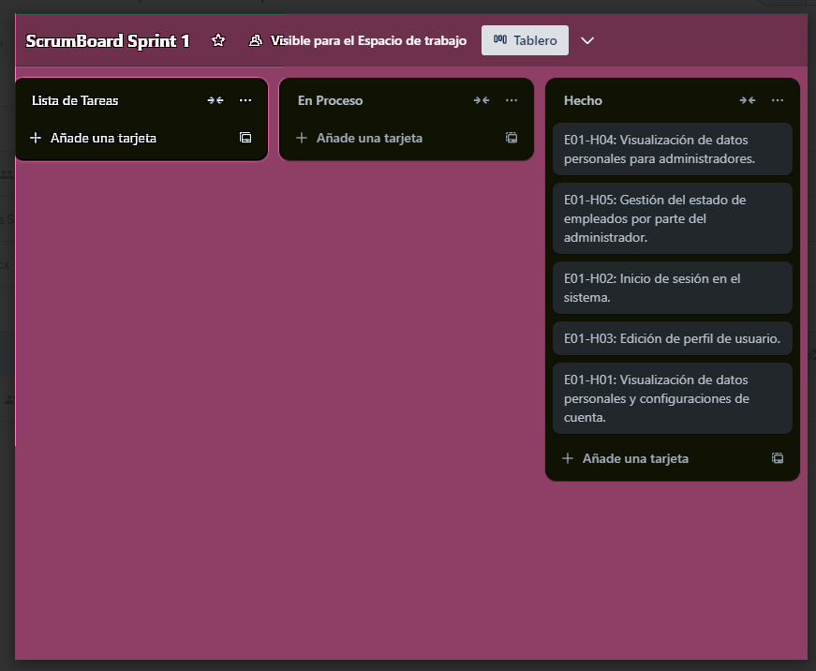  
<https://trello.com/b/Be0baLuV/scrumboard-sprint-1>